1. Is the Python Standard Library included with PyInputPlus?

Ans: No, PyInputPlus is not a part of python standard library, it needs to be installed explicitly using the command (pip install PyInputPlus)

2. Why is PyInputPlus commonly imported with import pyinputplus as pypi?

Ans: You can import the module with import pyinputplus a pyip so that you can enter a shorter name when calling the module’s functions.

3. How do you distinguish between inputInt() and inputFloat()?

Ans: inputInt() – Function accepts an integer value. This also takes additional parameters min, max, greater Than and less Than for bounds, and it always returns an int.

inputFloat() – Function accepts a floating – point numeric value. This also takes additional min, max, gearter Than and less Than for bounds parameters and always returns a float.

4. Using PyInputPlus, how do you ensure that the user enters a whole number between 0 and 99?

Ans: PyInputPlus module provides a function called as inputInt() which only return only integer values. Inorder to restrict the input between 0 to 99 i’ll use parameter like min and max to ensure that user enter the values between the defined range only.

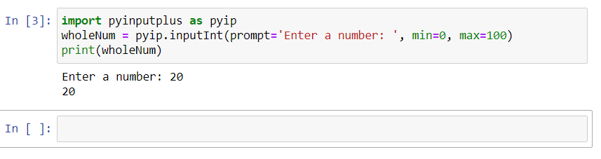

5. What is transferred to the keyword arguments allowRegexes and blockRegexes?

Ans: we can use allowRegexes and blockRegexes keyword arguments to take list of regular expression string to determine what the pyiputplus function will reject or accept valid input

6. If a blank input is entered three times, what does inputStr(limit=3) do?

Ans: The statement inputStr(limit=3) will throw two exceptions validationException and RetryException. The first exception is throw because black values are not allowed by inputStr() function by default. It we want to consider blank values as valid input, we have to set blank=True.

7. If blank input is entered three times, what does inputStr(limit=3, default='hello') do?

Ans: Since the default parameter is set to hello, after blank input is entered three times intead of raising RetryLimitException exception, the function will return hello a response to the calling function.